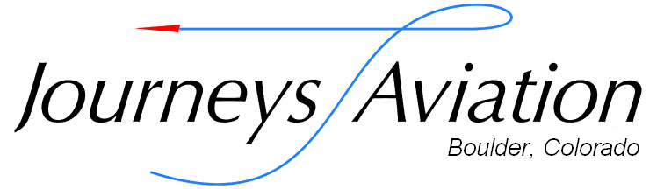

2021 Aircraft Rental Price List (as of September 2021)

Tail  Number | Make & Model |  | Hobbs Hourly Wet Rates |  |  |  | Non-Member Rates | Solo Insurance Requirements in addition to check out | Equipment
 |  |  | Member |  | w/$1,000 Pre-Pay
N23117 | Cessna 150H / 150HP | $117 |  | $113.49 |  | $132 |  | Student | Garmin 696GPSMAP, ADS-B Out
N6316S | Cessna 150G / 150HP | $120 |  | $116.40 |  | $135 |  | Student | Garmin 175 GPS, Dual Nav/Com, Lynx 9000 ADS-B In/Out
N235ND | Diamond DA20-C1 | $124 |  | $120.28 |  | $139 |  | Student | Garmin 375 GPS, Aspen E5, ADS-B out  -VFR ONLY-
N333RX | Cessna 172G Skyhawk  180HP Conversion | $125 |  | $121.25 |  | $140 |  | Student | Garmin 430 GPS, ADS-B In/Out
N52993 | Cessna 172P Skyhawk | $128 |  | $124.16 |  | $143 |  | Student | Garmin Aera 660, GTX 327 ADS-B In/Out
N6694E | Cessna 172N Skyhawk | $140 |  | $135.80 |  | $155 |  | Student | Garmin 430W, Dual Garmin G5, Stratus ADS-B In/Out
N9049H | Cessna 172M Skyhawk  180HP Conversion | $140 |  | $135.80 |  | $155 |  | Student | Garmin 650W, Dual Garmin G5, ADS-B In/Out, Const. Speed Prop
N3547L | Cessna 172S Skyhawk  180HP | $134 |  | $129.98 |  | $149 |  | Private | Bendix King KLN94 GPS  uAvionix ADS-B Out
N401SS | Cessna 182P Skylane | $154 |  | $149.38 |  | $169 |  | Pvt & 100TT, A/C checkout, 15 T-O & l landing in M&M | Garmin 430, Garmin Aera 560, Lynx 9000 ADS-B In/Out
N501EL | Citabria 7ECA | $165 |  | $160.05 |  | $180 |  | Dual instruction only | Garmin 496 GPS, GTX 327 Transponder

Membership Dues

Standard Monthly
$35/month

Annual
$360

For more information, questions or concerns about memberships please feel free to contact our office. (303) 449-4210

Flight Instruction Rates

Primary
(Introductory Flights/Private Pilot)
$55 per hour

Advanced
(Ratings past Private, BFR’s)
$60 per hour

Multi-Engine/Mountain/Tailwheel
$70 per hour

**Note: Flight Instruction is billed for the total time spent with CFI and not just flight time. Anything less than the total duration of the lesson is at the discretion of the instructor.

